

**UNIVERSITI TUNKU ABDUL RAHMAN**

FACULTY OF INFORMATION AND COMMUNICATION TECHNOLOGY

**BACHELOR OF INFORMATION SYSTEM (HONS)**

**INFORMATION SYSTEM ENGINEERING**

**UCCD3184 Mobile Applications Development**

**Group Practical Assignment**

Group Members : Lim Yangzheng (0803577)

Yee Kar Chun

Andrew Leong Mun Wah

Lecturer : Mr. Tou Jing Yi

Submission Date : Tuesday, April 09, 2013

**Explanation of the Application**

In this group assignment, we have came up with an application that is able to help to keep track of their financial expense. This is an application that is able to benefit for all kind of people. What this application does is that, user is able to enter their daily expense records into the application. The application will then stored the data into the local application database. These information will then be kept for future use, such as looking for old expenses records and also generating statistical data.

When the application is started up, a splash screen will be shown with a fade in and fade out animation. The size of the logo will change according to the orientation.

 

Figure 1: Splash Screen(Vertical View) Figure 2: Splash Screen(Horizontal iew)

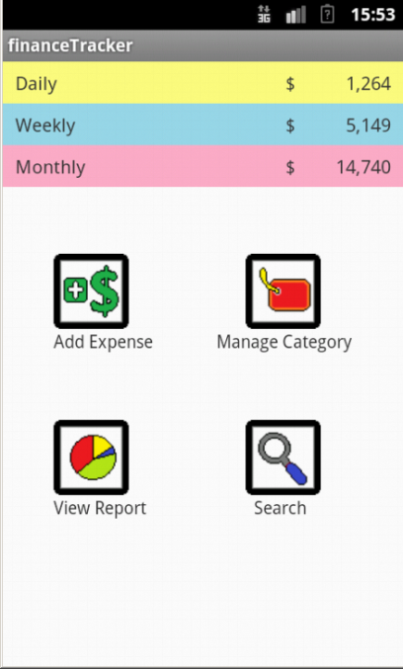 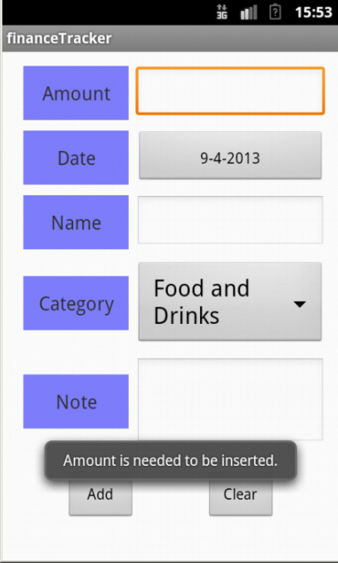 Figure 3: Home Screen Figure 4: Add Expense Screen

A home screen will then be shown (Figure 3), in the top of the screen shows three rows of information. The first row is the summary of the daily expense, the second is the weekly expenses summary, and the last row is the monthly expense summary. With this function the user is able to easily keep track of their expense. There are also four navigation buttons shown in the home page.

We will first look at the add Expense function, as shown in Figure 4 users are able to insert the expense details and store it. The amount field are required to be filled and will show a Toast message if the user did not place it. The default values for date is the date of today and the category will be the first category. The name and notes field are optional to be filled.

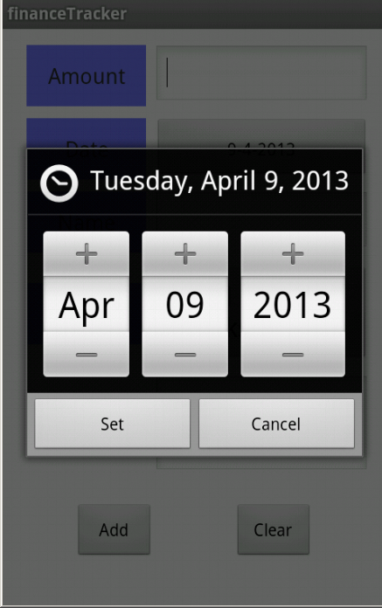 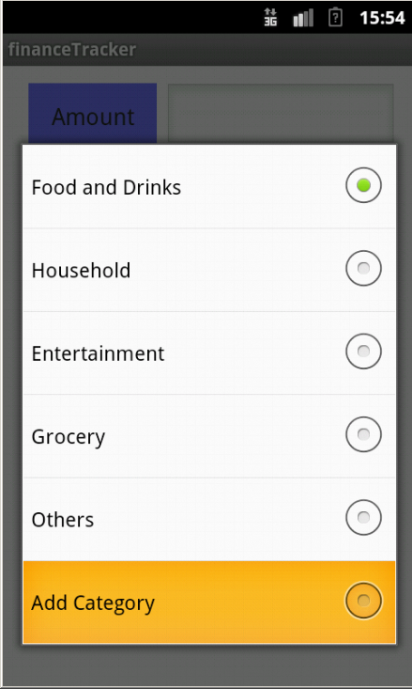

Figure 5: Date Picker Figure 6: Choosing Category

The date field will show a date picker for the user to select the date value. The category field will show the inserted categories in a Spinner. In the last selection there is an option for the user to include an extra category. An alert window will pop up to prompt for the input. Validation such as no whitespaces only input and existing categories will be checked. When a new category is enter a Toast message will be shown.

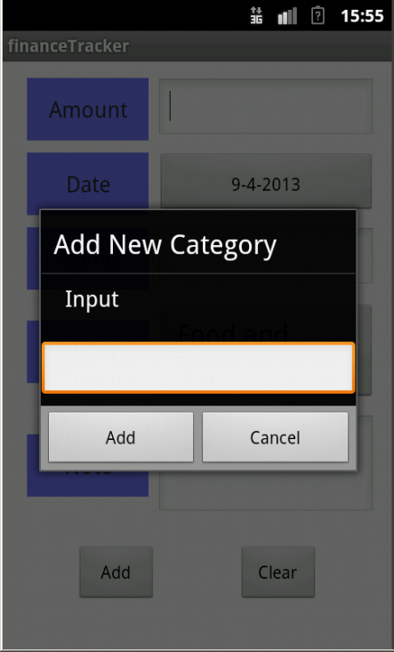 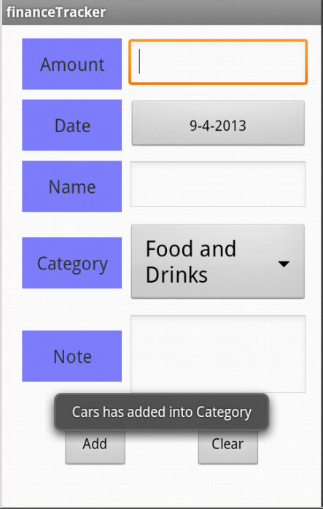

Figure 7: Alert for new category name Figure 8: Adding new Category

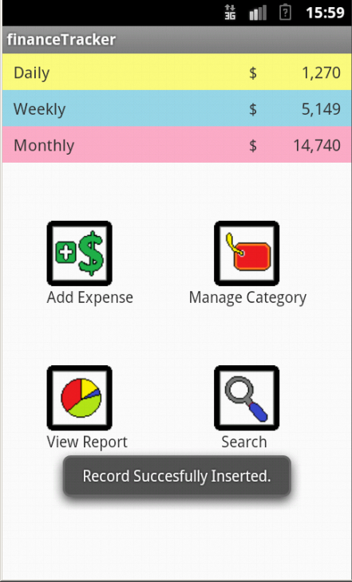 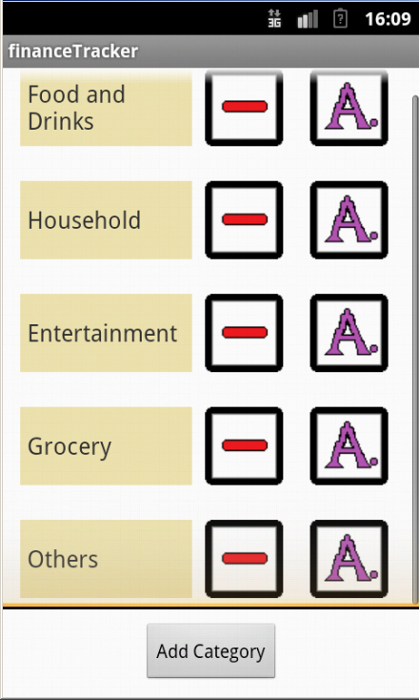

Figure 9: An expense is inserted Figure 10: The category Screen

After the expense is inserted, the application will go back to the home screen and a Toast message will shows the record is successful inserted. The next function is the manage category function. This function is to show the expense categories that are available. User are able to alter the values in this interface. A new category is able to added with the “Add Category” button. The name of the category is also able to change by pressing the edit name button (button with the letter A.). To remove a category the user just need to press the remove button (The button with a minus sign) of the corresponding category. After confirming the deletion a Toast message that shows the record is removed will be shown.

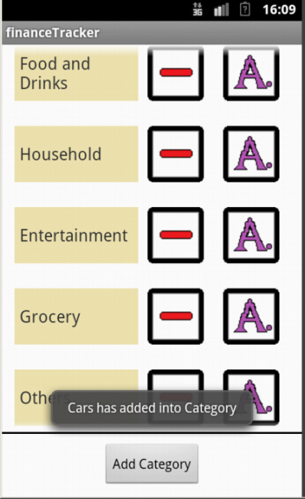 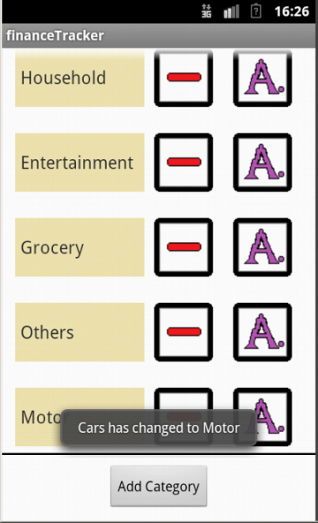

Figure 11: Inserting a new Category Figure 12: Changing a category name

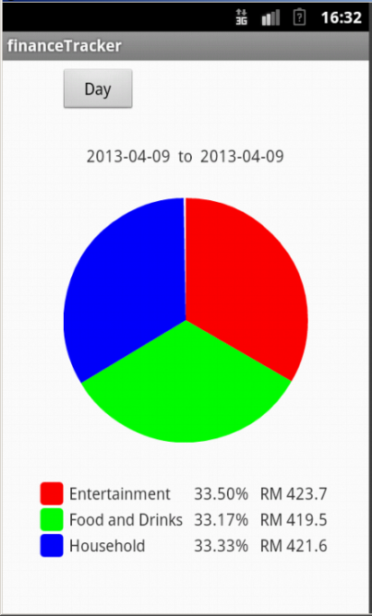 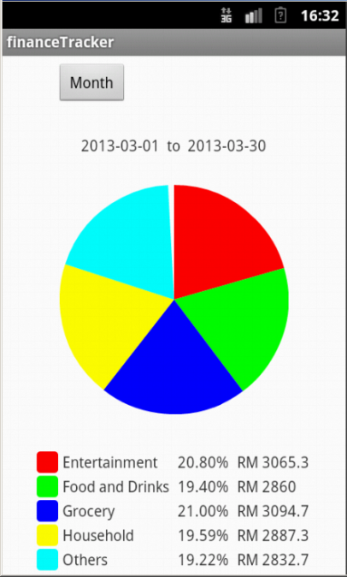

Figure 13: Pie Chart for Daily Statistic Figure 14: Pie Chart for Monthly Statistic

In the report function, the application will show the statistical data of the records of expenses. The default view will be the monthly data. The results is grouped in terms of categories and the percentage and the total expense for the category for the current month will be shown.

By clicking on the button on the top left corner which display the current type of view the user is able to switch between day, week, and month. The date range of the respective type will also be shown on the top of the pie chart. Day shows the daily activity expenses of today, Week shows the weekly expense of this week, and Month shows the monthly expense activity of this month.

The search function enables the user to find either a particular expense or a group of expense. The user is able to lower the search results by changing the date range. The date range will auto changes the start and end date if the wrong range is included. The name field enables user to find the name of the expense. This function is useful as the user is able to trace the history of the same kind of item. The category field allows the user to select a particular category or having to search for “All Categories”. When all categories is included, every existing category will be included in the search.

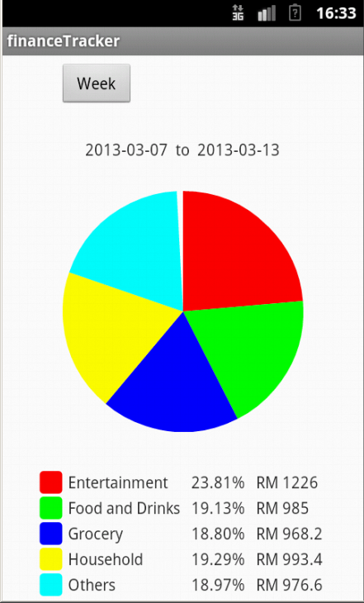 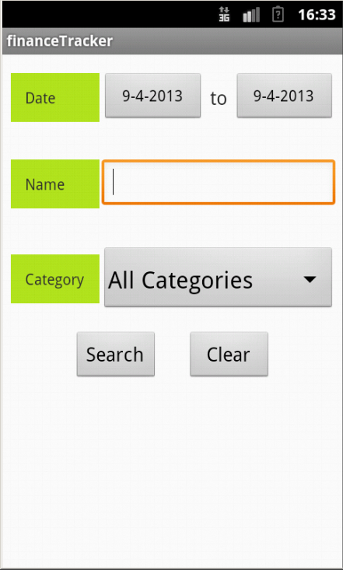

Figure 15: Pie Chart for Week Figure 15: Searching Screen

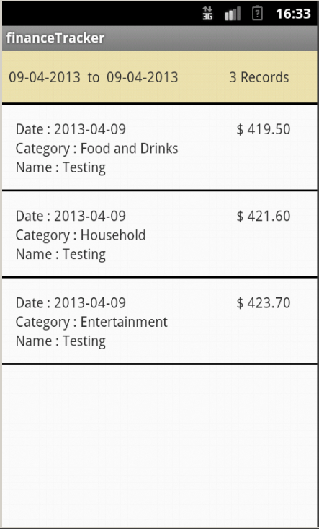 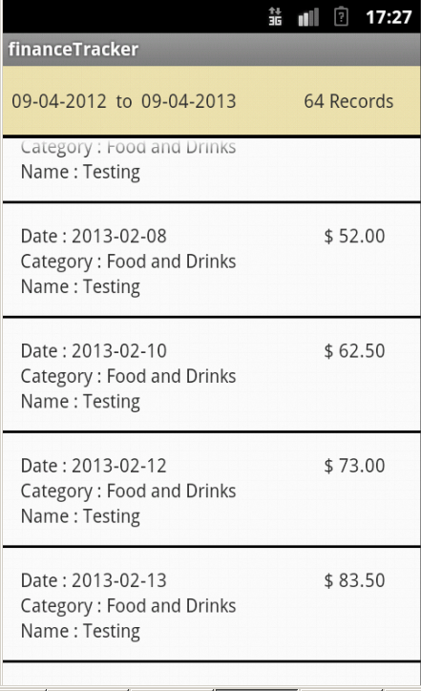

Figure 17: Result of the search Figure 18: Search for the same Category

There are two buttons in the search view, the clear button will clear the name field and the search button will perform a query with the database of the application. After all results are retrieved, it will displayed in another screen which is the Result view Screen. The result view screen consists of a header row which states the date range of the search and also the total records found. The details of the result expense will shown in a scrollable view. The date, amount, category and name of the expense will be shown.

**Conclusion**

After completing this assignment we have learned to make use of the database of android and also understand the importance of it. Although this is just a simple application but from here we have realize the need of storing information in a mobile device. Unfortunately, due to time constraints many of the intended features such as deleting records, editing expense, and also more details on statistical report generation could not be done. We hope that in the future, we are able to make of the knowledge that is learnt here.